show databases;

create database bank155;

use bank155;

create table branch(

name varchar(30),

city varchar(35),

assets varchar(25),

primary key(name)

);

desc branch;

create table bankaccount(

accno int,

name varchar(30),

balance int,

primary key(accno),

foreign key(name) references branch(name)

);

desc bankaccount;

create table bank_customer(

customer_name varchar(30),

customer_street varchar(25),

customer_city varchar(40),

primary key(customer_name)

);

desc bank_customer;

create table depositer(

customer_name varchar(30),

accno int,

primary key(customer_name,accno),

foreign key(customer_name) references bank_customer(customer_name),

foreign key(accno) references bankaccount(accno)

);

desc depositer;

create table loan(

loan_number int,

name varchar(30),

amount int,

primary key(loan_number),

foreign key(name) references branch(name)

);

desc loan;

insert into branch values("sbi_ch","blr",50000);

insert into branch values("sbi_re","blr",20000);

insert into branch values("sbi_sh","bb",30000);

insert into branch values("sbi_pa","del",40000);

insert into branch values("sbi_jan","del",70000);

select * from branch;



select *from bank_customer;



select * from depositer;



insert into loan values(1,"sbi_ch",1000);

insert into loan values(2,"sbi_re",2000);

insert into loan values(3,"sbi_sh",3000);

insert into loan values(4,"sbi_pa",4000);

insert into loan values(5,"sbi_jan",6000);

select * from loan;

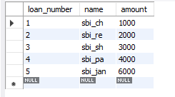

alter table branch

change assets assets_lakhs real;

select * from branch;

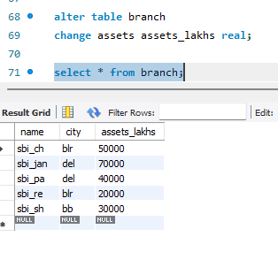

select d.customer_name from depositer d,

bankaccount b where b.name="sbi_re" and d.accno=b.accno group by d.customer_name having count(d.accno)>=2;

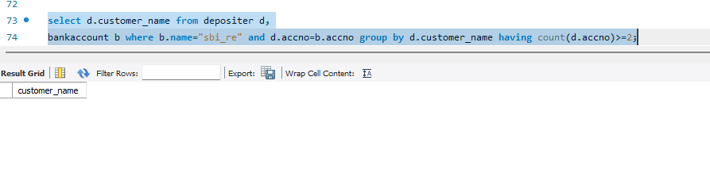

SELECT d.customer_name

FROM depositer d

JOIN bankaccount b ON d.accno = b.accno

WHERE b.name = 'sbi_re'

GROUP BY d.customer_name

HAVING COUNT(d.accno) >= 2;

CREATE VIEW br AS

SELECT name, SUM(amount) AS total_amount

FROM loan

GROUP BY name;

select * from br;

